Homework 5

# Q 7.9

## 7.9 (a) the data points AND THE regression line in log-log coordinates

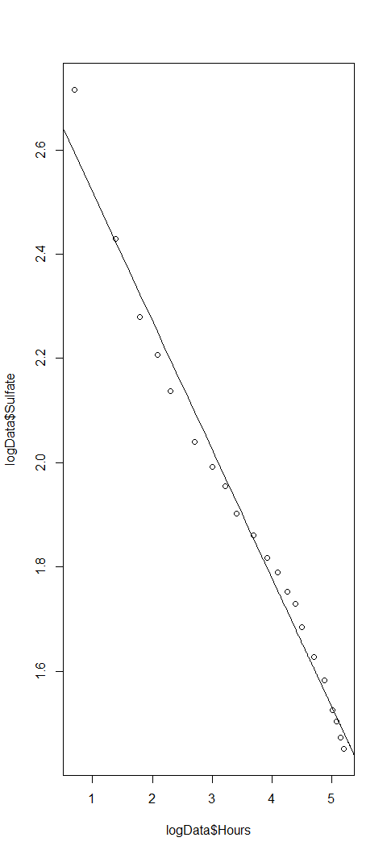

## 7.9 (B) THE data points and the regression curve in the original coordinate

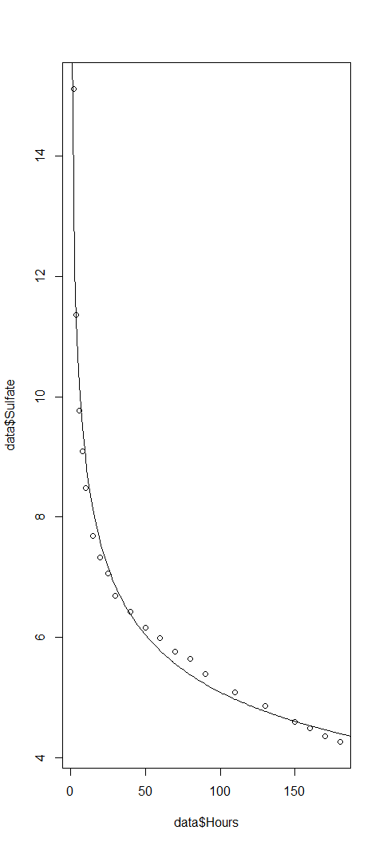

## 7.9 (c)

### residual against the fitted values in log-log coordinates.

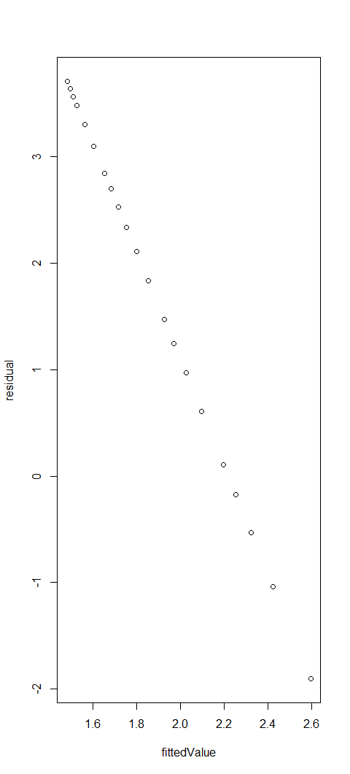

### residual against the fitted values in original coordinates.

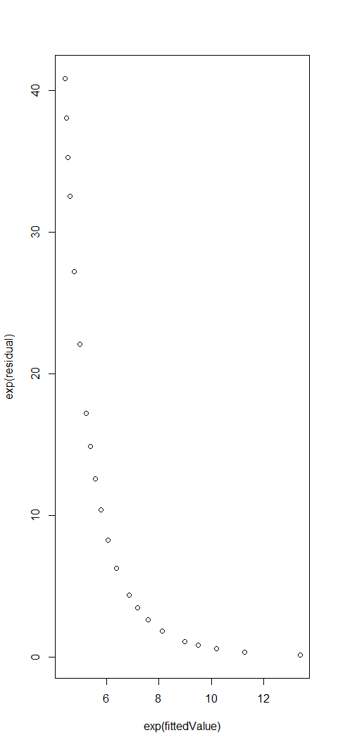

## 7.9 (d)

Regression is good. It models data points very well. Since data-set is very small we cannot check for overfitting. If log-log coordinates, regression model fits very well to the given dataset.

# Q 7.10

## 7.10 (a) residual against the fitted values for your regression

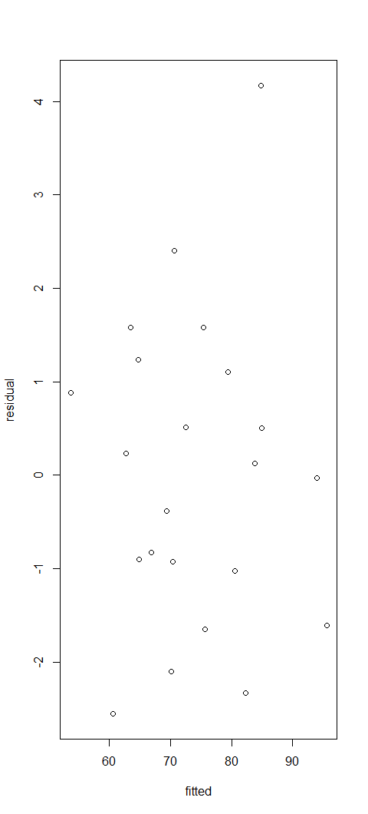

## 7.10 (b)

### residual against the fitted values in cube root coordinates

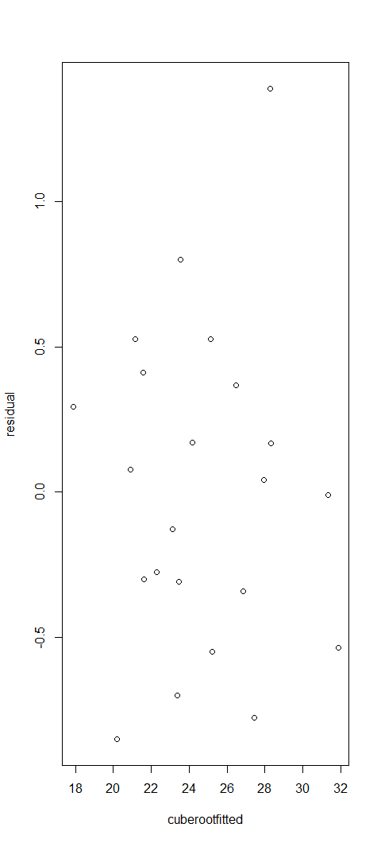

### residual against the fitted values in original coordinates

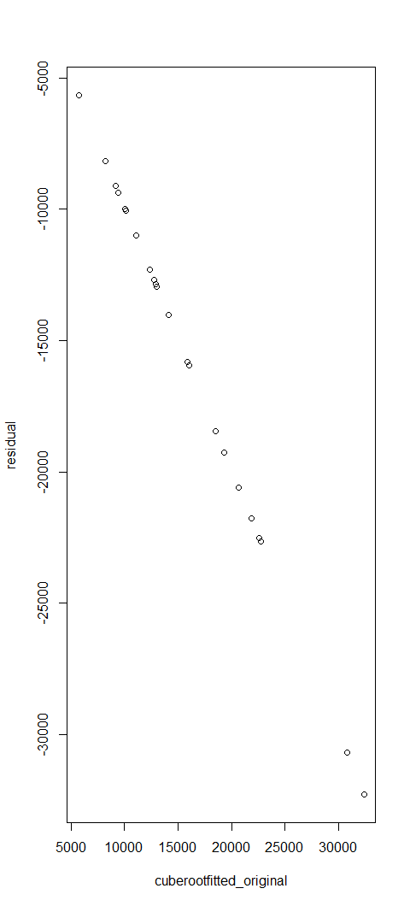

## 7.10 (c)

Model generated using cube roots is better as the residual can be represented as nearly linear function of fitted value in original coordinated.

# 7.11

## 7.11 (a) residual against the fitted values

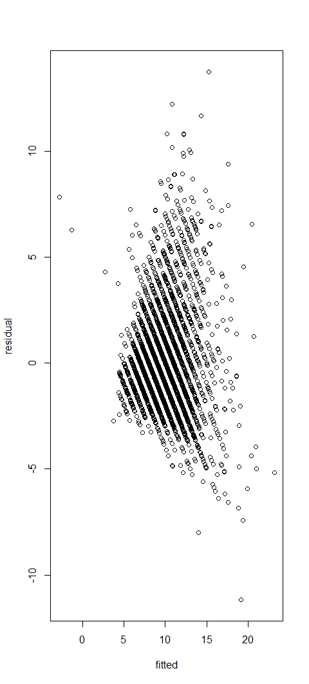

## 7.11 (b) residual against the fitted values

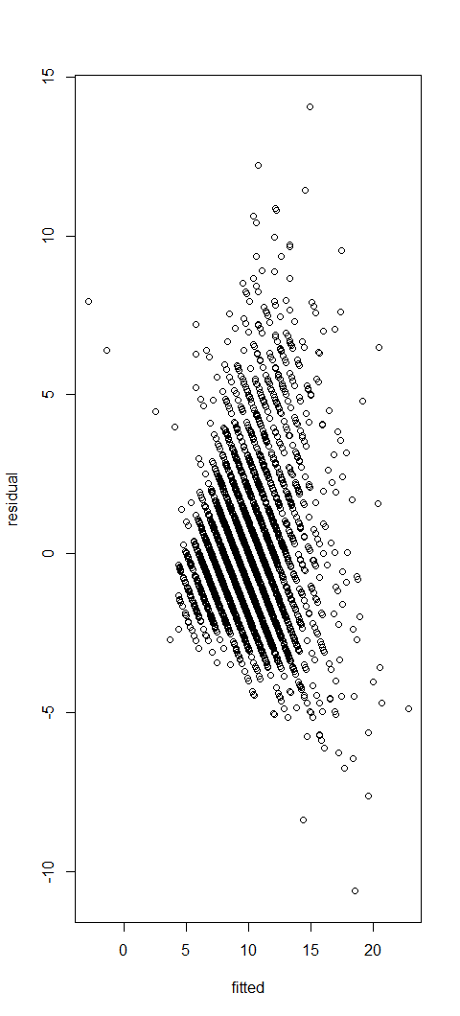

## 7.11 (c ) residual against the fitted values

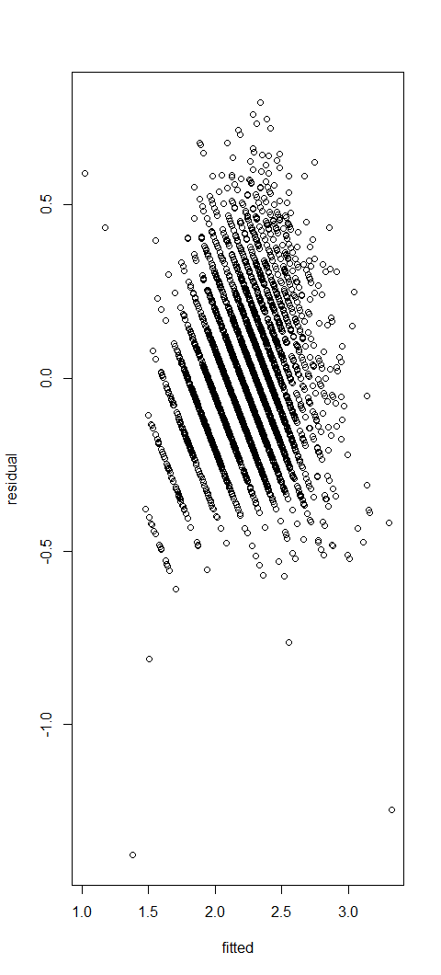

## 7.11 (d ) residual against the fitted values

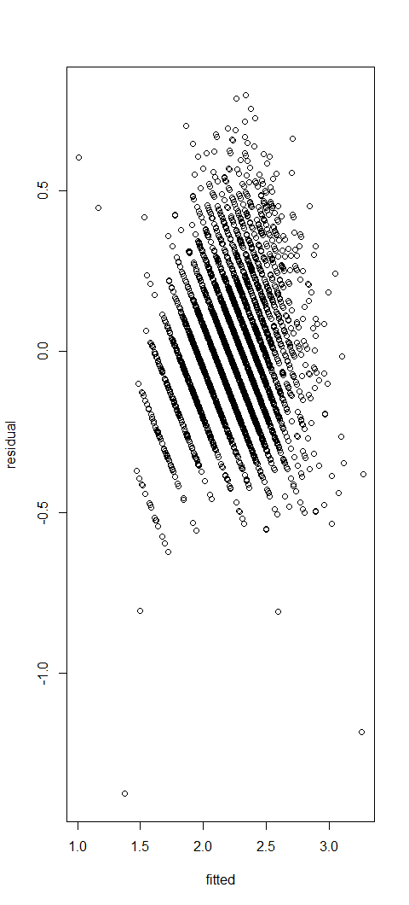

## 7.11 (e )

Model for prediction log of age in more appropriate logically to replace the presented prediction logic as the measurements grow exponentially as the age increases.

## 7.11 (f)

